LEARNING REFLECTION PLATFORM
A Synopsis for
Minor Project
BACHELOR OF TECHNOLOGY in COMPUTER SCIENCE & ENGINEERING
BY
Amita Kumari EN23CS301121
Anaaya Bhattacharya EN23CS301123
Anjali Gour EN23CS301136

Under the Guidance of

Prof. Deepika Saraswat

Prof. Jyotsana Goyal

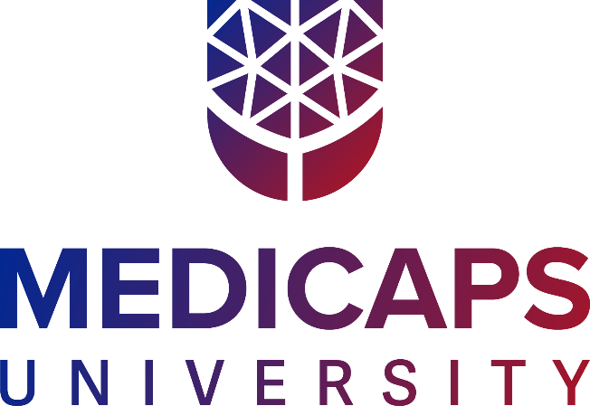

Department of Computer Science & Engineering Faculty of Engineering
MEDICAPS UNIVERSITY, INDORE- 453331

Jan - June 2026

Introduction
In today’s digital era, students consume learning content from multiple online platforms such as YouTube, blogs, documentation websites, and shared links. Due to time constraints, lack of prerequisites, or cognitive overload, students are often unable to fully understand a concept immediately. Research in self-regulated learning shows that reflection and metacognitive awareness significantly improve long-term retention and conceptual clarity [1].
Students usually save these resources intending to revisit them later. However, there is no structured mechanism to track conceptual understanding or readiness for exams or interviews. Existing task management platforms focus on completion tracking rather than conceptual clarity [2].
The Learning Reflection Platform is designed to address this gap by focusing on learning clarity and reflective progress instead of simple task completion.

Literature Review
Several existing systems attempt to support productivity and learning. However, they do not directly address structured clarity tracking.
First, task management platforms such as Todoist and Notion allow users to organize tasks and deadlines. These systems primarily focus on completion monitoring and productivity enhancement but do not provide mechanisms to track conceptual understanding or unresolved learning topics [2].
Second, Learning Management Systems (LMS) such as Moodle and Google Classroom offer structured course delivery and assessments. These platforms are institution-controlled and mainly support formal academic environments. They provide limited flexibility for managing external, self-directed learning resources.
Third, educational research emphasizes reflective and self-regulated learning approaches. Studies indicate that tracking one’s level of understanding and identifying learning difficulties improves retention and exam readiness [1][3]. However, no dedicated platform currently provides structured management of unresolved learning items in self-directed digital learning contexts.
Thus, the identified gap is that existing systems either manage tasks or deliver structured content, but they do not support structured tracking of conceptual clarity for independently saved learning resources.

Problem Definition
In the modern digital learning environment, students frequently use multiple platforms for acquiring knowledge. These platforms include video-sharing services, blogs, technical documentation sites, and shared study materials. Due to time constraints, insufficient prerequisite knowledge, cognitive overload, and lack of organization, students often save learning resources without fully understanding them.
Over time, saved links become scattered and difficult to manage. There is no systematic way to track unresolved concepts, measure clarity levels, or prioritize learning before important events such as examinations or job interviews. Existing tools emphasize task completion rather than conceptual mastery. Consequently, important topics remain partially understood or forgotten, negatively affecting academic performance and preparation readiness.

Objectives
The primary objectives of the Learning Reflection Platform are as follows:
- To provide a centralized web-based platform for organizing learning resources.
- To track learning progress based on clarity levels categorized as Confused, Partially Clear, and Clear.
- To allow users to define readiness deadlines for examinations, interviews, or other goals.
- To encourage reflective learning by enabling identification of difficulty reasons.
- To implement reminder mechanisms for revisiting learning items.
- To track interaction frequency and revisit history for analytical purposes.

Methodology
1. Development Approach
The system will follow a modular and incremental development methodology. Each module will be independently designed, implemented, and tested before integration. This structured approach ensures scalability, maintainability, and systematic expansion of features.
The proposed modules include:
- User Authentication Module.
- Learning Item Management Module.
- User Profile Module
- Metadata Extraction Module.
- Reminder and Priority Evaluation Module.
- Interaction Tracking Module.
- Dashboard & Analytics Module
- Notification Module
2. System Architecture
The Learning Reflection Platform will adopt a Client-Server Architecture consisting of three layers.
The first layer is the Frontend Layer, which will be developed using HTML5, CSS3, JavaScript (ES6), and React. This layer will handle the user interface, dashboards, clarity indicators, and in-app notifications.
The second layer is the Backend Layer, which will be implemented using Node.js and Express.js. It will manage business logic, user authentication, metadata extraction, reminder evaluation, and API communication.
The third layer is the Database Layer, which will use MongoDB with Mongoose for schema modeling. This layer will store user profiles, learning items, metadata, interaction history, and reminder data.
Communication between frontend and backend components will occur through REST APIs using JSON-based HTTP requests.
3. Functional Workflow
The functional workflow of the proposed system begins with user registration and authentication on the platform. After successfully logging in, the user adds learning resource links that represent concepts or topics requiring further understanding. Once a link is submitted, the backend processes the request and extracts available metadata from the provided resource. The processed learning item, along with its extracted information, is then securely stored in the database.
Subsequently, the user assigns a clarity level indicating their current understanding, selects relevant difficulty reasons, sets a priority level, and defines a target readiness date based on upcoming academic or professional goals. The system continuously evaluates these deadlines and generates appropriate reminders to encourage timely revision. Additionally, user interactions such as link visits and access frequency are tracked for analytical purposes. This structured workflow promotes reflective learning and clarity tracking rather than simple bookmarking or task listing.
Societal impact or benefits to society
The Learning Reflection Platform contributes to society by promoting structured and reflective learning practices. First, it encourages students to consciously evaluate their understanding rather than passively consume content. Second, it supports self-directed digital education, which is increasingly prevalent with platforms such as YouTube and online course providers. Third, it reduces learning gaps by tracking confusion levels and difficulty reasons. Fourth, it enhances exam and interview preparedness through readiness-based prioritization. Finally, it improves digital organization by reducing scattered bookmarks and forgotten study materials.
Conclusion
The Learning Reflection Platform addresses a significant gap in contemporary digital education by emphasizing conceptual clarity and reflective learning. While existing tools manage tasks or deliver structured academic content, they do not support clarity-based tracking of independently saved learning resources. By integrating centralized management, clarity assessment, reminder mechanisms, and interaction tracking, the proposed system promotes disciplined and self-regulated learning habits. This approach enhances long-term retention, reduces conceptual gaps, and improves academic and career preparedness.

References
Journal References
[1]. Zimmerman B.J., “Becoming a self-regulated learner: An overview.”, Theory Into Practice, Volume 41, Issue 2, pp: 64–70, 2002.
[2]. Bellotti V., Dalal B., Good N., Flynn P., Bobrow D., Ducheneaut N., “What a To-Do: Studies of Task Management Towards the Design of a Personal Task List Manager.”, Proceedings of the SIGCHI Conference on Human Factors in Computing Systems, pp: 735–742, 2004.

Book References
[3]. Schraw G., Dennison R.S., “Assessing Metacognitive Awareness.”, Contemporary Educational Psychology, Academic Press, pp: 460–475, 1994.

URL References
[4]. Moodle Learning Management System, https://moodle.org, accessed on 27/02/2026 at 10:00 AM.
[5]. Google Classroom, https://classroom.google.com, accessed on 27/02/2026 at 10:05 AM.
[6]. React Official Documentation, https://react.dev, accessed on 27/02/2026 at 10:10 AM.
[7]. Node.js Official Website, https://nodejs.org, accessed on 27/02/2026 at 10:12 AM.
[8]. MongoDB Official Website, https://www.mongodb.com, accessed on 27/02/2026 at 10:15 AM.

